CMPEN 454 - Project 2

By: Rui Zheng, Jacob Minnich, Chenning Zhang, Nelson Huang



Summary/Outline

The project seeks to test our understanding with various image processing techniques by allowing us to write a computer algorithm that uses those techniques. The final purpose is to generate a blending picture. Our project is divided into four sub tasks.

* Projecting 3D points into 2D pixel locations
* Triangulating back into a set of 3D scene points
* Computing the error between the triangulated points and original 3D points
* Computing epipolar lines between the two views

The goal of this project is to implement forward and inverse camera projections and perform triangulation from two cameras, in order to reconstruct pairs of matching 2D image points using 3D reconstruction, and finding epipolar lines in the individual frames.

The first task we did was to project 3D points into 2D pixel locations. We were given a motion capture data, which contains a 21614x12x4 array of numbers. The first dimension is the frame number, the second is the joint number, and the last is the joint coordinates + confidence score for each joint. For each frame in the video, we want to map 12 points on certain parts of the person’s body. Next, we want to triangulate each of the 12 pairs of 2D points to estimate the recovered 3D point position. We can do this by converting each point into a viewing ray, which we can derive using this formula:

$P_{w }= -R^{T}T+λR^{T}K^{-1}P_{m}$

$P_{w}=vue.location.' + c*vue.Rmat^{T}*vue.Kmat^{-1 }*projection_{pixel}$

In other words, the camera location is defined as a 3x1 matrix which we defined to be $P_{w}$. Once we mapped the projected 3D points into 2D pixel locations and triangulated them back into a set of 3D points, we measured the error between the triangulated points and the original 3D points. To do so, we simply applied the Euclidean distance, which is denoted by this formula:

$D=\sqrt{(X-X_{1})^{2}+(Y-Y_{1})^{2}+(Z-Z_{1})^{2}}$

We know that there will be errors in our computed locations because of inaccuracies in the projection equations and inaccuracies with floating point calculations in Matlab.

Lastly for this project, we computed epipolar lines between the two camera views. We decide to use method 2 where we find 2 points on the viewing ray in one camera and project the viewing ray into the other camera.

**Procedural approach**

From the given camera parameters, we can conclude that:

* Kmat = Perspective projection = [f, 0, ox; 0, f, oy; 0, 0, 1], scale = 1;
* Rmat = rotation matrix
* Pmat = rotationMatrix * translationMatrix
* prinpoint = center offset
* Position = camera location in 3D space

External parameters include Rmat (orientation), position, Pmat. Internal parameters include, foclen (focal length), prinpoint, and Kmat (which is a combination of foclen and prinpoint). To verify the connection of Pmat, Rmat, and location of the camera, we used the following code in matlab:

position = vue2.position;

ps = [1 0 0 -1 * position(1); 0 1 0 -1 * position(2); 0 0 1 -1 * position(3); 0 0 0 1];

rt = vue2.Rmat;

Verify = rt * ps - vue2.Pmat

If the assumption is correct, verify would be a 3x4 matrix full of zeros, which turns out to be correct.

1. 2D projection

As explained above, we have been given the Kmat and Pmat, which are needed to calculate the pixel coordinates of the projected motion capture points. The formula to calculate this is:

x = mocapJoints(mocapFnum,joint,1);

y = mocapJoints(mocapFnum,joint,2);

z = mocapJoints(mocapFnum,joint,3);

pst = [x; y; z; 1];

$pstpixel = vue2.Kmat * vue2.Pmat * pst$

For visualization, we print the pixel location on video frame by:

vid2Frame = mark(vid2Frame, round(pstpixel(1)/pstpixel(3)), round(pstpixel(2)/pstpixel(3)));

Where mark() simply make a red square around the input pixel location. We show the result in a consecutive set of images, which is roughly the following:



Vue2 2D projection image



Vue 4 2D projection

1. Viewing ray calculation

As explained above, viewing ray is derived by:

$P_{w}=c + n *u =vue.location.' + n*vue.Rmat^{T}*vue.Kmat^{-1 }*projection_{pixel}$

We use matlab function linsolve() to find the magnification n for each viewing ray and thus the 2 points on the viewing ray. The reconstructed 3D point will be the average of the 2 projected point. Euclidean distance between the reconstructed point and the actual 3D point is calculated as shown.

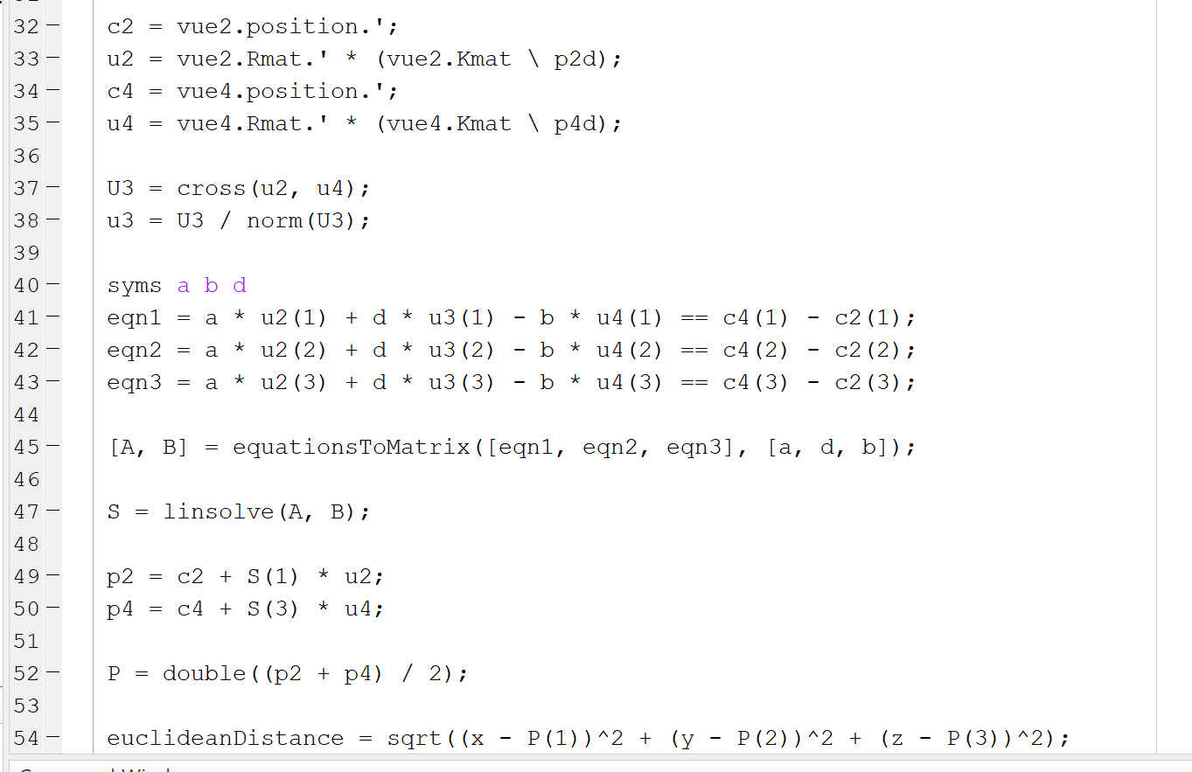

1. Epipolar lines

Epipolar lines are calculated by projecting the viewing ray of one camera to the other. This can be done by finding 2 points on one of the viewing rays, project them to the pixel plane to the other camera, and draw a line between them. Doing this with all 12 pairs create the epipolar lines from each camera.

Simple Flowchart



Experimental Observations

For the coding portion of this project, we separated each tasks into several functions. The first task we did, in order to project 3D points into 2D pixel locations, is to load the capture data file and extract x, y, z locations for the joints in a specific frame in the video, as well as computing the confidence value with the ‘mocapJoints’ function. Since there are 12 3D points we needed to map, we used a for-loop in order to create the four values for each of the 12 points. We noticed that there is one point in particular that does not have a confidence value of 1. This caused one of our mappings to be thrown completely off, such that the point that was supposed to be mapped on the person’s left ankle was mapped somewhere else in the frame. The code ran smoothly and the result of the 12 points being mapped on the person is shown below in Figure 1. We know that our code works as expected because changing the frame would not cause the mapping of points to be thrown off.

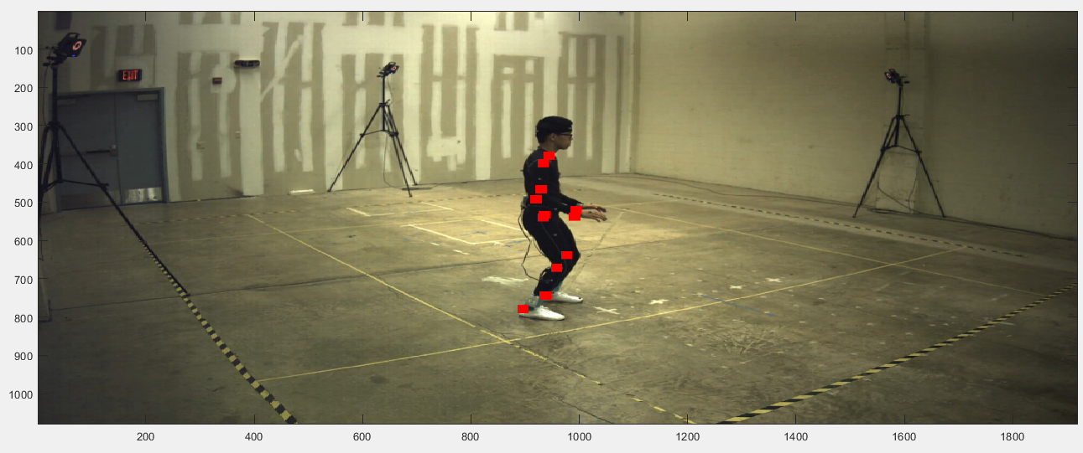

Figure 1

We also wrote a separate function that computes the triangulated points. For this task, it was only a matter of plugging in values into a formula and find the value for P, which is the 3D point location that is closest to both sets of rays. Our value for P was fairly realistic. And, as for the error computations, we used the euclidean distance formula and the program worked as expected. In the pictures below, the variable ‘P’ was the triangulated value we computed and the variable ‘sum’ is supposed to represent the errors between the triangulated values and the original points. Our result is small enough to be a reasonable error value.

|  |  |
| --- | --- |
|  |  |

Quantitative Results:

|  |  |  |  |  |  |
| --- | --- | --- | --- | --- | --- |
|  | Max | Median | Minimum | Mean | Standard deviation |
| Right Shoulder | 2.7967e-11 | 9.7818e-13 | 2.5421e-13 | 1.0304e-12 | 8.2812e-13 |
| Right Elbow | 3.9159e-11 | 9.7134e-13 | 2.3437e-13 | 1.0488e-12 | 1.2214e-12 |
| Right Wrist | 2.5243e-12 | 9.6927e-13 | 1.1369e-13 | 1.0042e-12 | 3.7844e-13 |
| Left Shoulder | 2.5950e-12 | 9.9191e-13 | 2.2737e-13 | 1.0242e-12 | 3.5189e-13 |
| Left Elbow | 2.1245e-11 | 1.0168e-12 | 2.2737e-13 | 1.0490e-12 | 6.7300e-13 |
| Left Wrist | 2.8125e-12 | 9.9760e-13 | 2.5421e-13 | 1.0236e-12 | 3.6881e-13 |
| Right Hip | 2.5809e-11 | 9.9273e-13 | 1.1369e-13 | 1.0311e-12 | 7.7820e-13 |
| Right Knee | 7.3800e-11 | 9.8620e-13 | 1.2711e-13 | 1.1468e-12 | 2.9614e-12 |
| Right Ankle | 4.5609e-11 | 9.9721e-13 | 1.8474e-13 | 1.0802e-12 | 1.4229e-12 |
| Left Hip | 2.2573e-11 | 9.9760e-13 | 1.3406e-13 | 1.0487e-12 | 7.0357e-13 |
| Left Knee | 3.3947e-11 | 9.9922e-13 | 5.6843e-14 | 1.0462e-12 | 9.8476e-13 |
| Left Ankle | 2.7963e-12 | 9.9527e-13 | 1.4921e-13 | 1.0241e-12 | 3.5851e-13 |

Qualitative Results:

* 3D Skeleton out of reconstructed 3D points with code (some code cut off but very redundant) [mocapFnum = 1000]

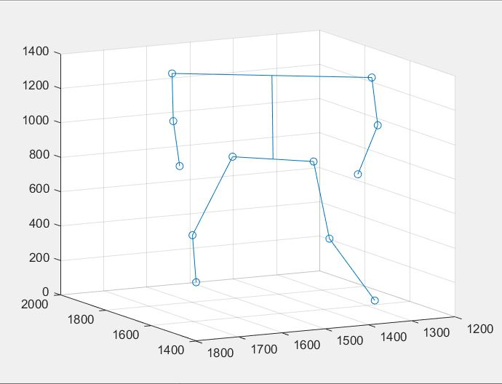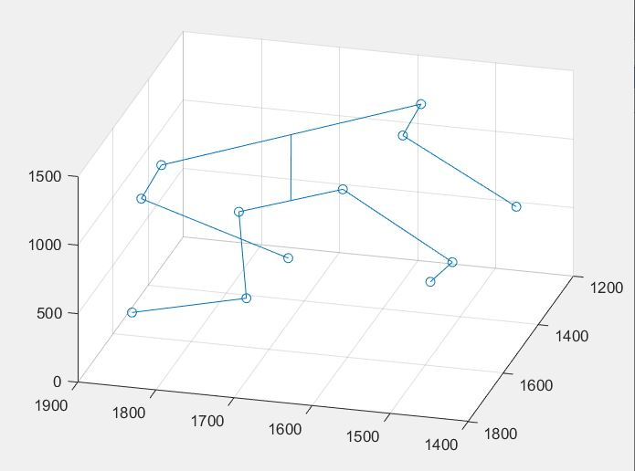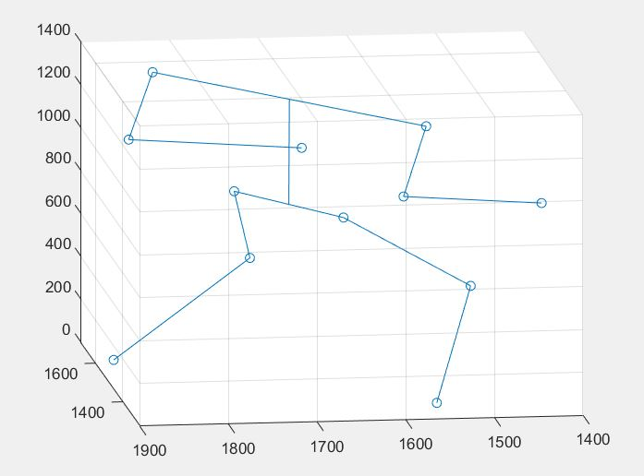

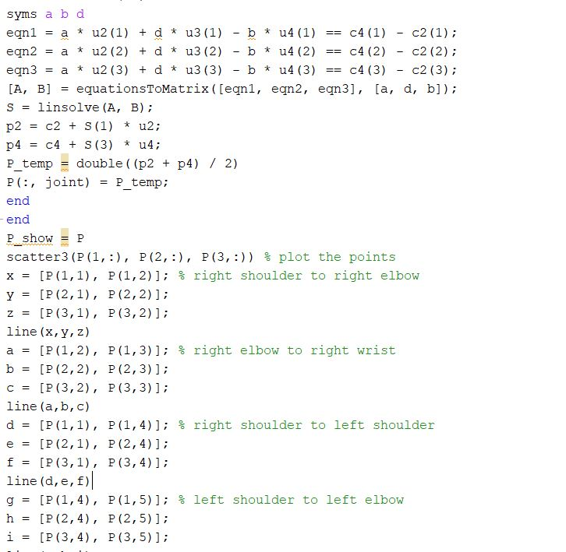

* 2D Skeleton with code to construct (some code cut off but very redundant) [mocapFnum = 1000]

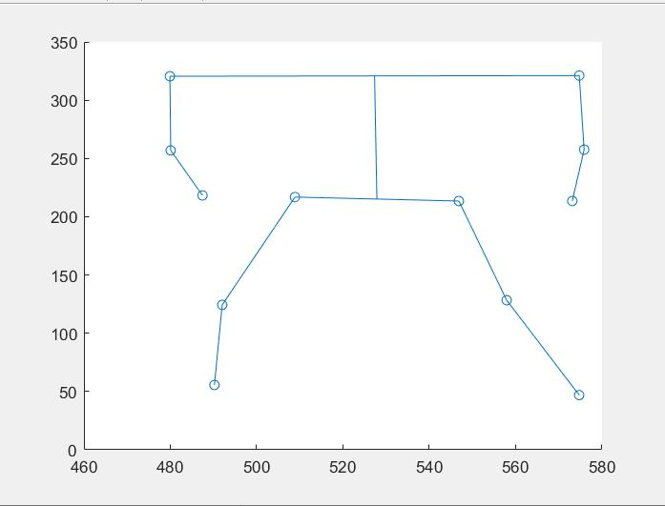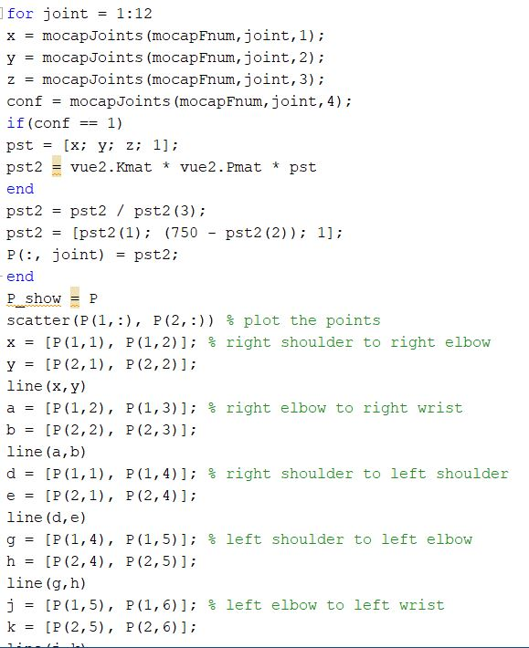

* 3D Skeleton from original 3D points (same code as reconstructed except P_temp = [x; y; z;], just making column out of Mocap input to put in matrix each iteration) [mocapFnum = 1000]

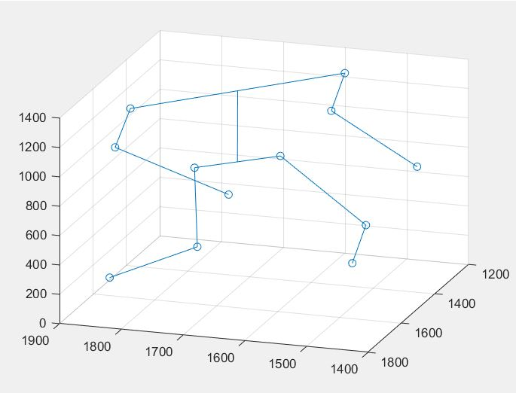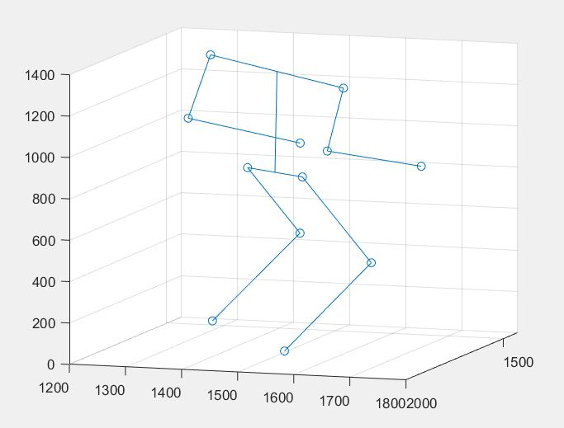

Epipolar projection

Frame number: 20000

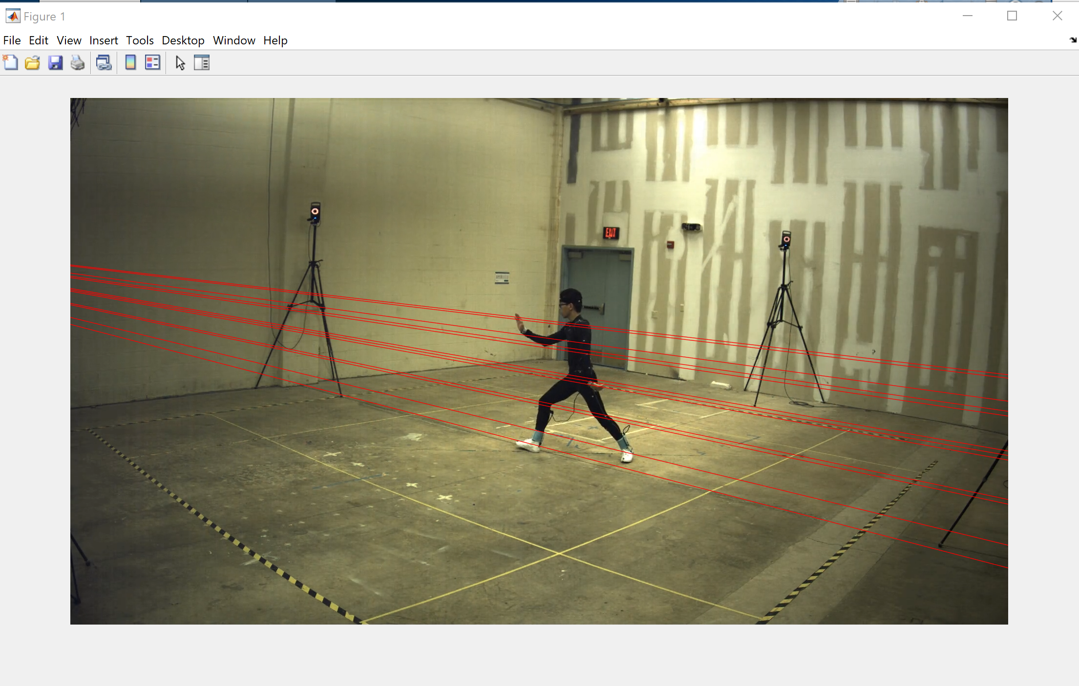

Epipolar lines in vue2

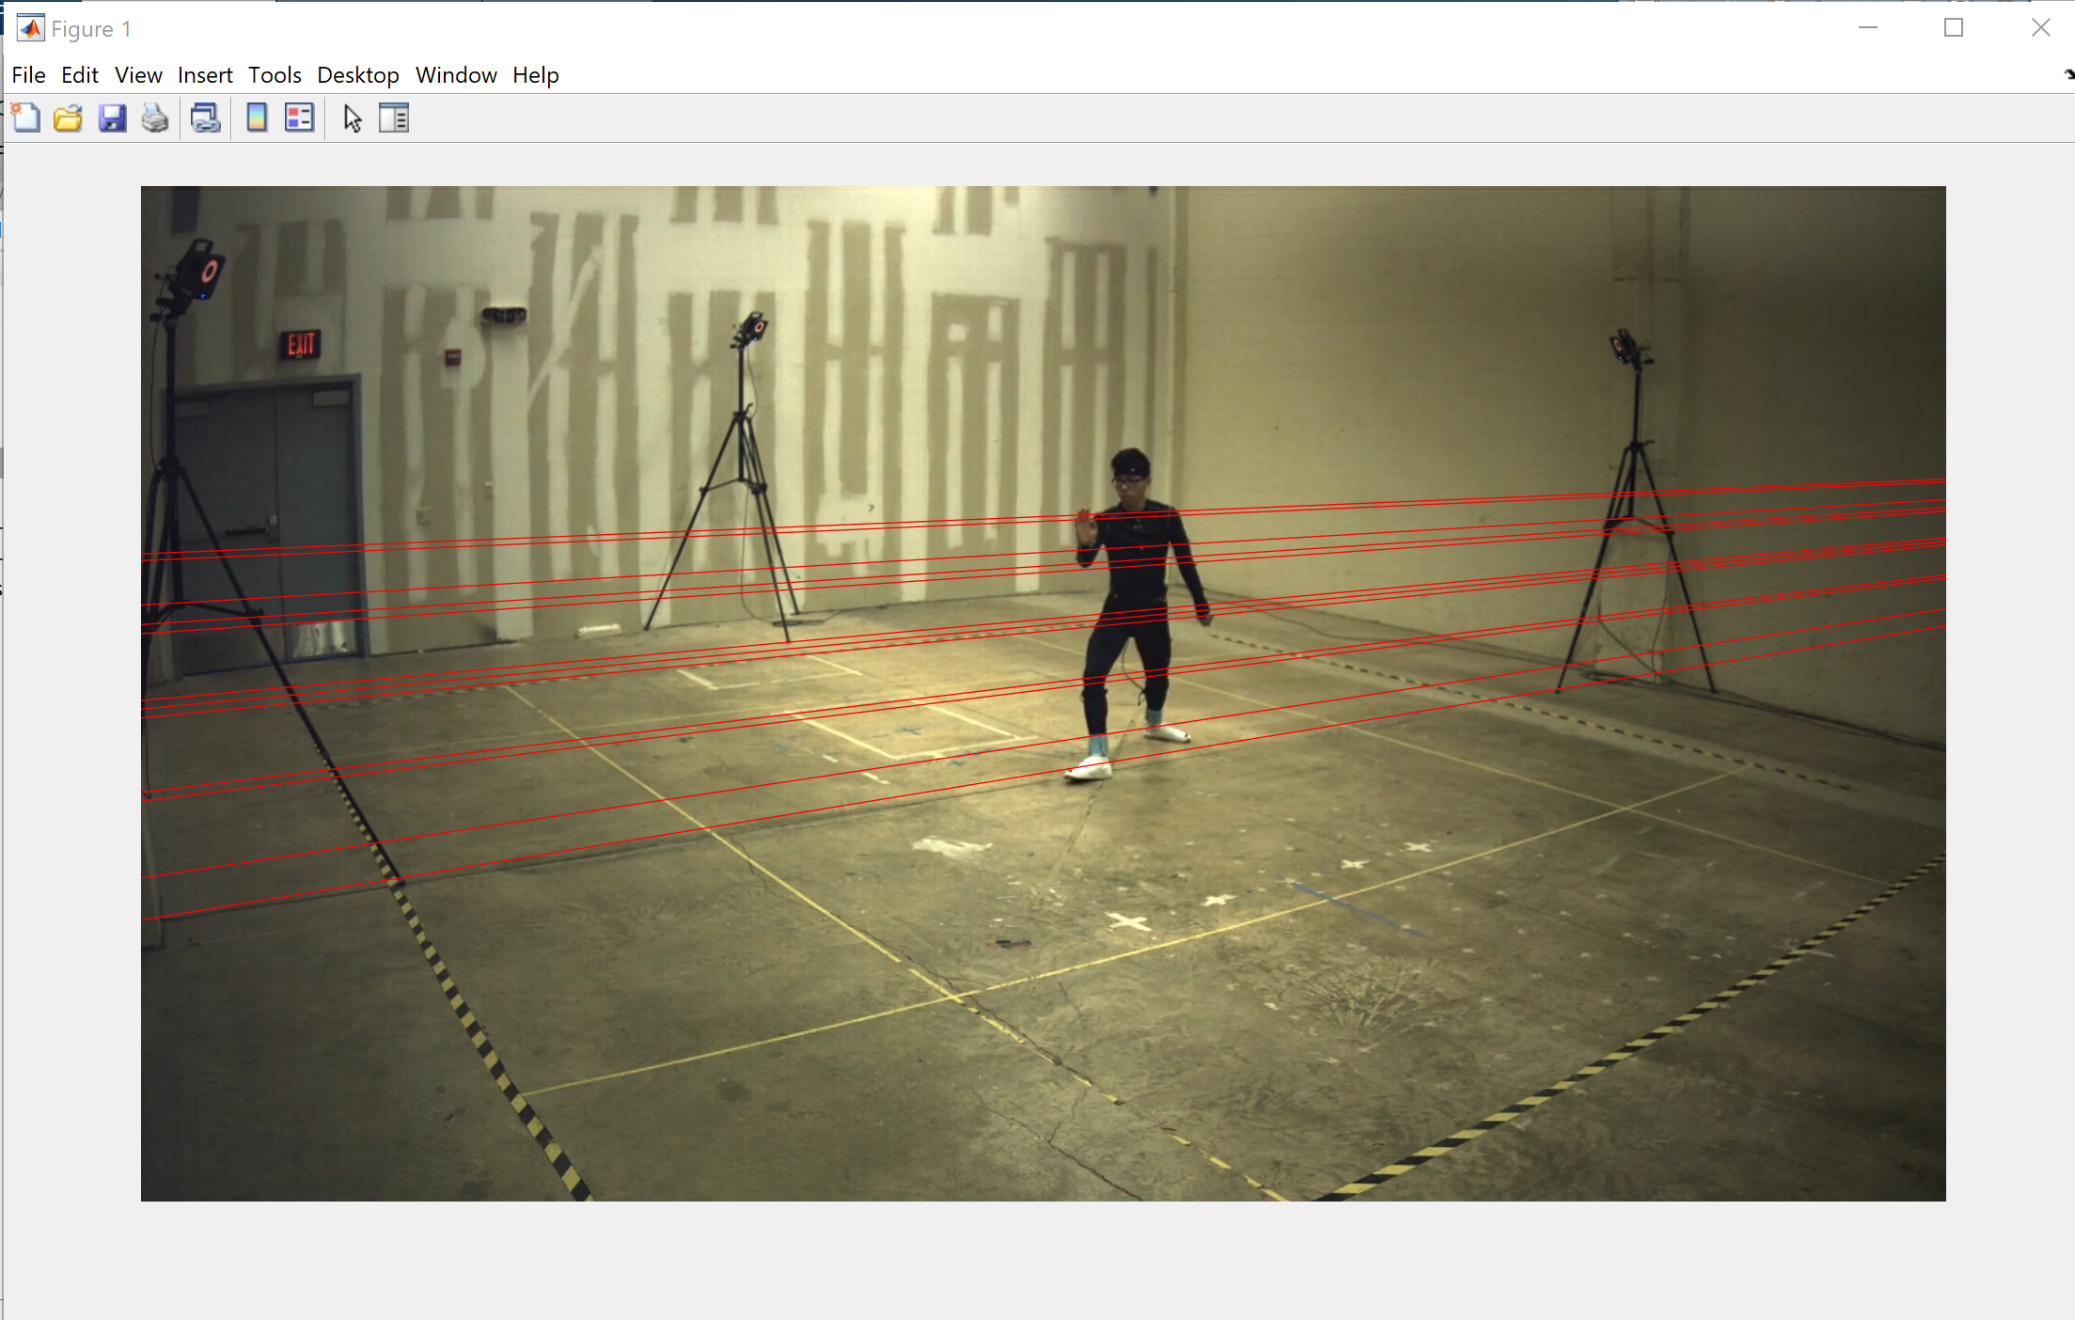

Epipolar lines in vue4

Contributions

Rui Zheng:

* Reading in 2D points
* Triangulation
* Epipolar Lines
* Checking Accuracy of 3D Reconstructed Points
* Quantitative Results (Report)
* Qualitative Results (Report)

Nelson Huang:

* Reading in 2D points
* Triangulation
* Summary (Report)
* Outline (Report)
* Experimental Observations (Report)

Chenning Zhang:

* Reading in 2D points
* Triangulation

Jacob Minnich:

* Triangulation
* Epipolar Lines
* 2D, 3D, and 3D Reconstructed Skeletons
* Outline (Report)
* Qualitative Results (Report)